**Modulation Transfer Function (MTF)**

# Introduction

This experiment exercise explores a different method for measuring the Modulation Transfer Function (MTF) to assess the spatial resolution of a CT imaging system.

Rather than using an Impulse Function, which is difficult to implement practically, an Edge Function is employed. By analyzing the output image, the Edge Response Function (ERF) can be obtained. The Point Spread Function (PSF) is the derivative of the ERF, and the MTF is calculated by taking the Fourier Transform of the PSF. The Nyquist theorem highlights the importance of sampling frequency to accurately capture signal profiles. A shift-invariant system maintains consistent MTF and ERF across different locations within a 3D image.

1. EXPERIMENT
   1. **Materials**
2. Step Edge phantom (**Fig 1a**)
3. Blank phantom(**Fig 1b**)
4. 2L water
5. DeskCAT Multi-slice Optical CT Scanner

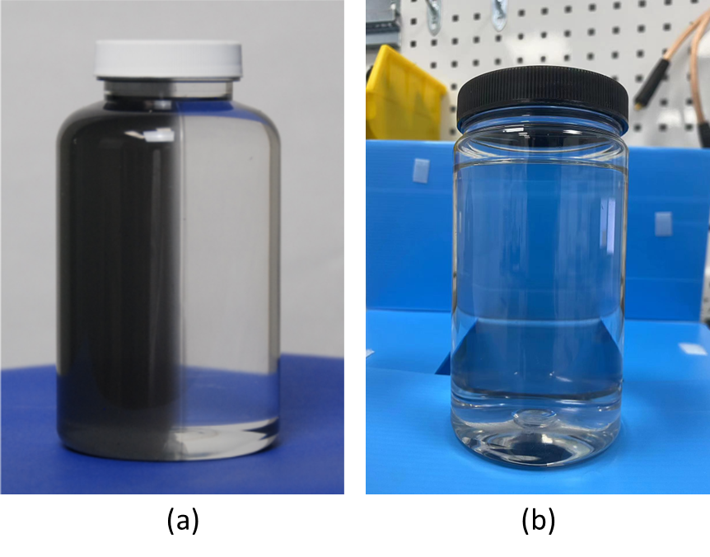

**Fig 1**(a)Step Edge phantom; (b) Blank phantom.

* 1. **Experimental Procedure**

1. Adjust the camera setting to 50% of maximum brightness (reducing the brightness allows for evenly distributed noise) by selecting **Scanner -> Camera Settings (Fig 2)**.

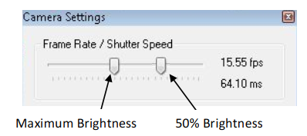

***Fig 2.*** *Camera setup diagram*

1. Under **Calibration $→$ Geometry Calibration**, select Auto-Cal and accept the values. Calibration must be done with NO phantom loaded.
2. Set the Number of projections on the side panel to acquire data.
3. Load the Blank phantom $→$ click on the left sidebar to **scan reference data**.
4. **Load the MTF Phantom** into the scanner by attaching the phantom to the Rotary Stage using the Jar Clamp and mounting the Rotary Stage onto the scanner. Acquire a Data Scan using the Start Data Scan button on the Side Panel. Wait for the scan to complete.
5. Under Reconstruction $→$ Reconstruction Options, select **Hamming Filter.**
6. Select the Voxel Resolution option and press Start Reconstruction to perform a reconstruction. Observe the reconstruction results using the software.
7. Reconstruction

## **Dataset**

Based on the aforementioned data acquisition steps, we collected raw data. The contents of the 'rawdata' folder are shown in **Fig 3**. The contents of the folder are explained as follows:

* ScanData: Projection data collected after placing the phantom.
* ScanRef: Projection data collected without the phantom in place.
* Calibration.xml: Geometric parameters.
* Info.xml: Contains the number of projections in ScanData and ScanRef.

文本

***Fig 3.***  *Example of the raw data folder.*

## **Reconstruction Steps**

The reconstruction process consists of two parts: the preprocessing part and the reconstruction part.

The preprocessing part includes the following steps:

* Flat field correction
* Geometric correction

Note: The offsets provided by the system often have some deviation, requiring manual adjustment to achieve the best results.

Reconstruction part: You can use the methods in the ASTRA Toolbox ([The ASTRA Toolbox — ASTRA Toolbox 2.1.0 documentation (astra-toolbox.com)](https://astra-toolbox.com/)) for reconstruction, or you can find other methods for reconstruction, such as iterative reconstruction, and deep learning reconstruction. **HOWEVER, FBP RECONSTRUCTION RESULTS MUST BE PROVIDED!**

1. Analysis
2. Include plots of the erf(x), psf(x) and MTF(f) for each of the acquired line profiles in your report.
3. A common criterion for determining the upper limit of spatial resolution of an imaging system is to determine the spatial frequency at which the MTF drops to 10% and 3%. Applying to the results from this experiment, what is the spatial resolution of this scanner?

**Report your results in both qualitatively images/plots as well as quantitative tables.**

1. Additional Questions

Investigate and determine how the MTF curve is changed with the number of projection views for a CT scan.